**610/1/2/3 Inst. Sch.**

**INSTRUCTIONS**

**FOR FINE ART**

**Paper 1/2/3**

**Jul/Aug 2016**

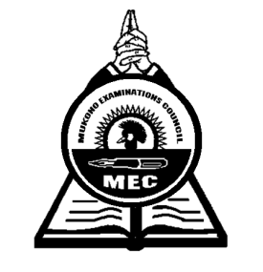

**MUKONO EXAMINATIONS COUNCIL**

**Uganda Certificate of Education**

**ART CONFIDENTIALS**

**Paper 1, 2 & 3**

**Note:**

*Great care should be taken that the information given below does not reach the candidates either directly or indirectly.*

**INSTRUCTIONS FOR PREPARING THE ITEMS**

*The information given here is only to facilitate the preparation of the examination.*

*THE Head teacher should make sure that the teacher responsible for preparing items gets all items before the examination.*

**Paper 1 (610/1)**

* One meter plain piece of cloth
* Stick of approx. 75cm in length
* One litre cylindrical tin
* Plant with three leaves and two large flowers in bright colours
* Two large balloons
* 2 large cards
* Medium size sauce pan
* A large ripe Pineapple with its head intact.
* A large water melon.
* A large sieve with a handle
* Two large oranges
* A large mature termite
* A Path, a building, some vegetation
* Aloe vera plant (Kigaji)

**Paper 2 (610/2)**

* A model
* A vest
* Pair of shorts
* A low traditional three legged stool (approximately 30cm high)
* A walking stick
* A short sleeved shirt / blouse
* A chair
* A table
* A large book (approx. 42cm wide when opened, 30cm long and spine is 4cm)
* A pen.

**Paper 3 (610/3)**

* Letrasets
* Plain white bond papers
* Rulers
* Coloured inks, pens, rubbers, strings, junk wire, paints, Markers etc
* Lino Blocks
* Sponge
* Pair of compass

***End -***